Parte superior do formulário

Pergunta 1: **Correto**

Is there a spending limit by default, when it comes to the spending limit for the Azure free account?

* 

**A. Yes**

**(Correto)**

* 

**B. No**

**Explicação**

**Answer: A**

There is a credit of 200 USD which is assigned to the Azure Free account and is limited to the first 30 days the account is active. This acts as a spending limit. The Microsoft documentation mentions the following.

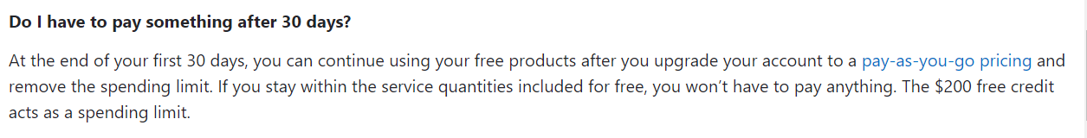

For more information on the commonly asked questions for the Azure Free account, please visit the below URL-

<https://azure.microsoft.com/en-us/free/free-account-faq/>

Parte inferior do formulário

Parte superior do formulário

Pergunta 2: **Incorreto**

A company wants to make use of Azure for the deployment of various solutions. They want to ensure that suspicious attacks and threats to resources in their Azure account are prevented. Which of the following helps prevent such attacks by using built-in sensors in Azure?

* 

**Azure AD Identity Protection**

**(Incorreto)**

* 

**Azure DDoS attacks**

* 

**Azure Privileged Identity Management**

* 

**Microsoft Defender for Identity**

**(Correto)**

**Explicação**

The Microsoft documentation states the below feature on the Microsoft Defender for Identity service.

Options A and C are incorrect since these are used for protecting identities in Azure AD.

Option B is incorrect since this is solely a solution to protect against DDoS attacks.

For more information on Azure Advanced Threat Protection, please visit the below URL-

[https://docs.microsoft.com/en-us/defender-for-identity/what-is](https://docs.microsoft.com/en-us/azure-advanced-threat-protection/what-is-atp)

Parte inferior do formulário

Parte superior do formulário

Pergunta 3: **Incorreto**

A company has just set up an Azure subscription. The company is planning to create several resource groups. By creating additional resource groups, would the company incur additional costs?

* 

**A. Yes**

**(Incorreto)**

* 

**B. No**

**(Correto)**

**Explicação**

**Answer: B**

Resource groups have no costs associated with them.

For more information on resource groups, please visit the below URL-

<https://docs.microsoft.com/en-us/azure/azure-resource-manager/resource-group-overview>

Parte inferior do formulário

Parte superior do formulário

Pergunta 4: **Correto**

A company has just set up an Azure virtual private connection between its on-premises network and an Azure virtual network. Would the company need to pay additional costs to transfer several gigabits of data from their on-premises network to Azure?

* 

**A. Yes**

* 

**B. No**

**(Correto)**

**Explicação**

**Answer: B**

Data transfers to the Azure data center are free.

The Microsoft documentation mentions the following.

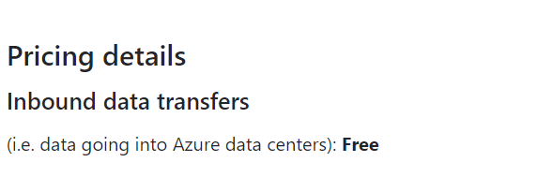

For more information on bandwidth pricing, please visit the below URL-

<https://azure.microsoft.com/en-us/pricing/details/bandwidth/>

Parte inferior do formulário

Parte superior do formulário

Pergunta 5: **Incorreto**

A company has just set up an Azure virtual private network connection between their on-premises network and an Azure virtual network. The company expects around 10 GB worth of data transfer per month from Azure to its on-premises network. Would the company need to pay additional costs for this data transfer?

* 

**A. Yes**

**(Correto)**

* 

**B. No**

**(Incorreto)**

**Explicação**

**Answer: A**

The company would need to pay additional costs for the data transfer.

A snippet from the Microsoft documentation mentions the following on data transfer prices.

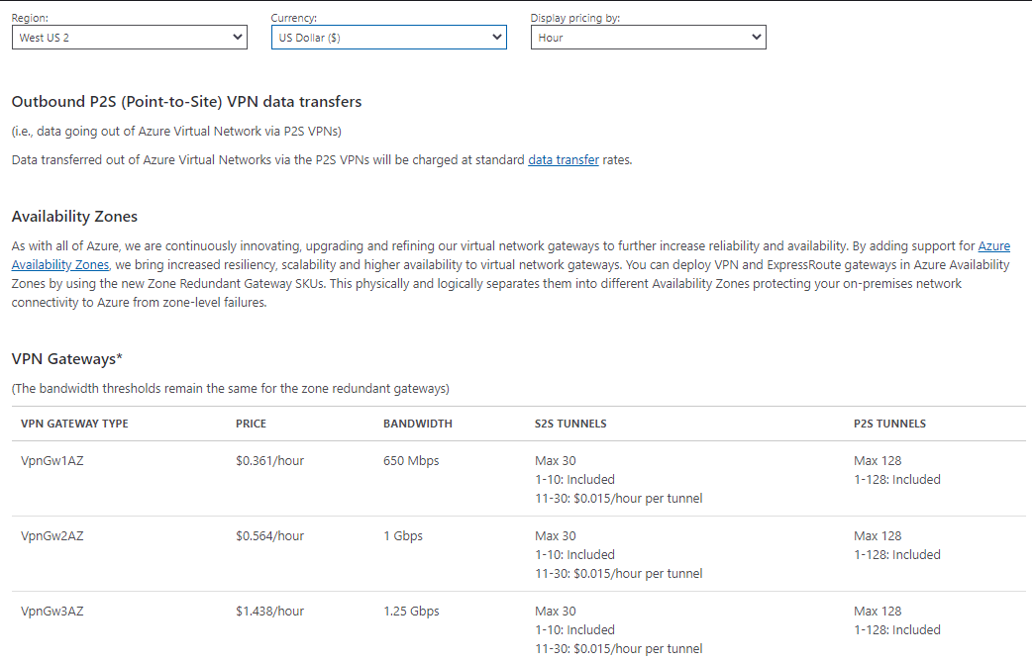

For more information on bandwidth pricing, please visit the below URL-

<https://azure.microsoft.com/en-us/pricing/details/bandwidth/>

Parte inferior do formulário

Parte superior do formulário

Pergunta 6: **Incorreto**

A company has a set of virtual machines defined in Azure. They want to find out which user shuts down a particular virtual machine in the last 7 days. Which of the following can help with this requirement?

* 

**A. Azure Advisor**

**(Incorreto)**

* 

**B. Azure Event Hubs**

* 

**C. Azure Activity Logs**

**(Correto)**

* 

**D. Azure Service Health**

**Explicação**

**Answer: C**

You see all operations on all resources via the use of Azure Activity Logs.

An example is given below shows operations being logged against the Virtual Machine service.

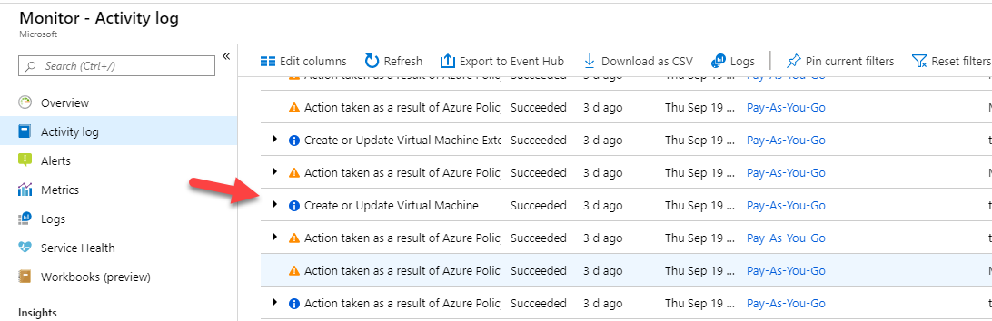

Since this is clear from the implementation, all other options are incorrect.

For more information on Activity Logs, please visit the below URL-

<https://docs.microsoft.com/en-us/azure/azure-monitor/platform/activity-logs-overview>

Parte inferior do formulário

Parte superior do formulário

Pergunta 7: **Incorreto**

A company wants to make use of an Azure service that can be used to store certificates. Which of the following could be used for storing certificates?

* 

**A. Azure Security Center**

* 

**B. Azure Storage Account**

* 

**C. Azure Key Vault**

**(Correto)**

* 

**D. Azure Identity Protection**

**(Incorreto)**

**Explicação**

**Answer: C**

You can store certificates in the Azure Key Vault service.

The Microsoft documentation mentions the following.

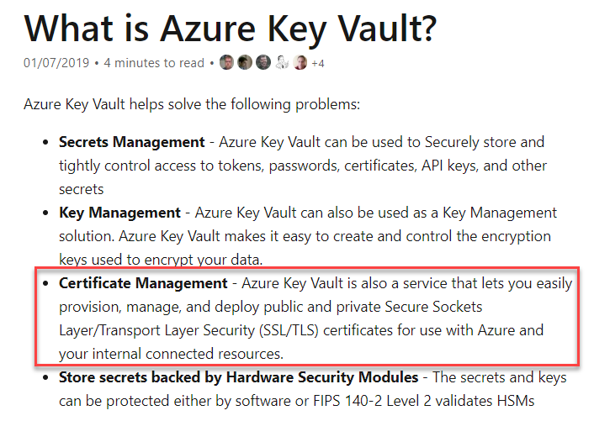

Option A is incorrect since this is used to increase the security posture of your resources defined in Azure.

Option B is incorrect since this is used for object, file, table and queue storage.

Option D is incorrect since this is used to protect Azure AD identities.

For more information on the Azure Key vault service, please visit the below URL-

<https://docs.microsoft.com/en-us/azure/key-vault/key-vault-overview>

PrevMark for review

Parte inferior do formulário

Parte superior do formulário

Pergunta 8: **Correto**

A company wants to deploy a set of Azure Windows virtual machines. They want to ensure that the services on the virtual machines are still accessible even if a single data center goes down.

They decide to deploy the set of virtual machines using scale sets across availability zones.

Would this fulfill the requirement?

* 

**A. Yes**

**(Correto)**

* 

**B. No**

**Explicação**

Answer: A

Azure virtual machine scale sets let you create and manage a group of identical, load-balanced VMs.

The Microsoft documentation mentions the following.

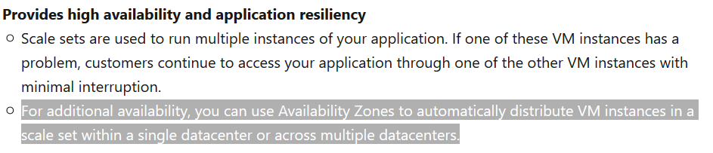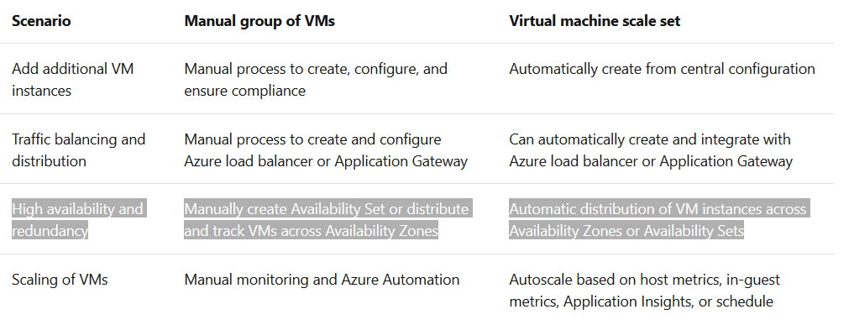

For more information on virtual machine scale sets, please visit the below URL-

<https://docs.microsoft.com/en-us/azure/virtual-machine-scale-sets/overview>

Parte inferior do formulário

Parte superior do formulário

Pergunta 9: **Correto**

A company wants to deploy a set of Azure Windows virtual machines. They want to ensure that the services on the virtual machines are still accessible even if a single data center goes down.

They decide to deploy the set of virtual machines to two or more regions with the required traffic configurations in place.

Would this fulfill the requirement?

* 

**A. Yes**

**(Correto)**

* 

**B. No**

**Explicação**

**Answer: A**

For the high availability of applications, we can have VMs deployed in one or more regions. To know about how to work with this architecture do refer to the following link-

<https://docs.microsoft.com/en-us/azure/architecture/reference-architectures/n-tier/multi-region-sql-server>

Parte inferior do formulário

Parte superior do formulário

Pergunta 10: **Incorreto**

A company wants to deploy a set of Azure Windows virtual machines. They want to ensure that the virtual machines' services are still accessible even if a single data center goes down.

They decide to deploy the set of virtual machines to two or more availability zones.

Would this fulfill the requirement?

* 

**A. Yes**

**(Correto)**

* 

**B. No**

**(Incorreto)**

**Explicação**

Answer: A

Yes, availability zones can be used in the case of data center-wide failure.

The Microsoft documentation mentions the following.

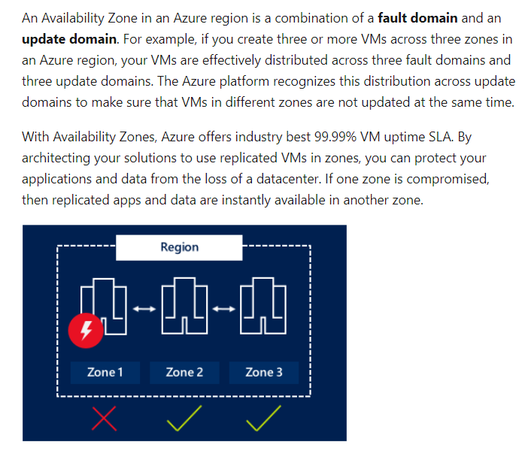

For more information on managing the availability of Azure windows virtual machines, please visit the below URL-

<https://docs.microsoft.com/en-us/azure/virtual-machines/windows/manage-availability>

Parte inferior do formulário

Parte superior do formulário

Pergunta 11: **Incorreto**

A company wants to start using Microsoft Azure. They currently also have a private cloud setup. Would it be required for them to migrate their entire private cloud model to achieve a hybrid cloud model?

* 

**A. Yes**

**(Incorreto)**

* 

**B. No**

**(Correto)**

**Explicação**

**Answer: B**

The Hybrid Cloud model combines both the public cloud and private cloud model. So, the company does not need to migrate their private cloud model to achieve the hybrid cloud model.

The Microsoft documentation mentions the following.

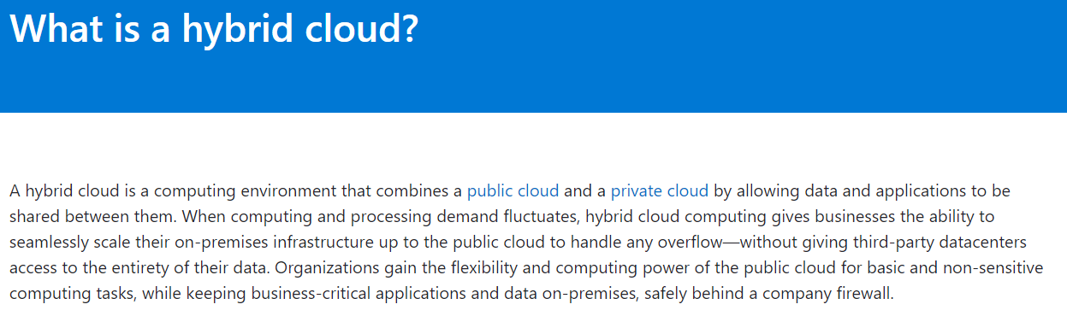

For more information on the hybrid cloud model, please visit the below URL-

<https://azure.microsoft.com/en-in/overview/what-is-hybrid-cloud-computing/>

Parte inferior do formulário

Parte superior do formulário

Pergunta 12: **Incorreto**

A company wants to implement a Hybrid Cloud model. Would Azure help them to scale the capacity of their on-premises setup to the public cloud?

* 

**A. Yes**

**(Incorreto)**

* 

**B. No**

**(Correto)**

**Explicação**

**Answer: B**

Working with Hybrid Cloud, does not allow the On-Premises infrastructure scale based on the demand. Scaling of resources can happen only in Cloud by the service provider i.e., Azure.

To know further about Hybrid Cloud, refer the below link.

* <https://azure.microsoft.com/en-in/overview/what-is-hybrid-cloud-computing/>

Parte inferior do formulário

Parte superior do formulário

Pergunta 13: **Incorreto**

Is it possible to manage external partners using the "Business-to-Business (B2B)" feature of Azure AD?

* 

**A. Yes**

**(Correto)**

* 

**B. No**

**(Incorreto)**

**Explicação**

**Answer: A**

Microsoft Azure has an Identity service known as Microsoft Azure Active Directory. Using the "Business-to-Business (B2B)" feature of Azure AD you can manage external partners while maintaining control over your own corporate data.

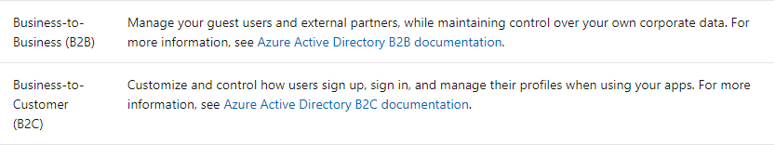

For more information on Identity solutions, please visit the below URL

<https://docs.microsoft.com/en-us/azure/active-directory/fundamentals/active-directory-whatis>

<https://docs.microsoft.com/en-us/azure/active-directory/b2b/compare-with-b2c>

Parte inferior do formulário

Parte superior do formulário

Pergunta 14: **Incorreto**

You have to identify the right category for both advantages/features.

* **Increases stability, reliability, and supportability**
* **Reduces capital expenditures and optimizes costs**

The above two features/advantages fall under which of the following category?

* 

**A. Software as a Service(Saas)**

* 

**B. Platform as a Service(PaaS)**

**(Incorreto)**

* 

**C. Infrastructure as a Service(IaaS)**

**(Correto)**

* 

**D. Serverless computing**

**Explicação**

**Answer: C**

**Infrastructure as a service (IaaS)** is a type of cloud computing service that offers essential compute, storage, and networking resources on demand, on a pay-as-you-go basis.

**Advantages of IaaS**

1. **Reduces capital expenditures and optimizes costs**
2. Increases scale and performance of IT workloads
3. **Increases stability, reliability, and supportability**
4. Improves business continuity and disaster recovery
5. Enhances security
6. Helps you innovate and get new apps to users faster

For more information on Infrastructure as a service, please visit the below URL:

[What is IaaS? Infrastructure as a Service | Microsoft Azure](https://azure.microsoft.com/en-us/resources/cloud-computing-dictionary/what-is-iaas/#overview)

Parte inferior do formulário

Parte superior do formulário

Pergunta 15: **Incorreto**

You have to identify the right category for each of the following Azure Services.

* Azure Kubernetes
* Business Intelligence (BI) services

Which of the following category does Azure Kubernetes come under?

* 

**A. Software as a service**

**(Incorreto)**

* 

**B. Platform as a service**

**(Correto)**

* 

**C. Infrastructure as a service**

* 

**D. Hardware as a service**

**Explicação**

**Answer: B**

Azure Kubernetes and Business Intelligence (BI) services comes under the category of “Platform as a service”.

**References:**

* <https://docs.microsoft.com/en-us/learn/modules/azure-networking-fundamentals/azure-virtual-network-fundamentals>
* <https://azure.microsoft.com/en-in/overview/what-is-paas/>

Parte inferior do formulário

Parte superior do formulário

Pergunta 16: **Correto**

A company wants to start deploying both Windows and Linux based Azure virtual machines. They also want to make use of availability zones for the underlying virtual machines. Could availability zones be used for both Windows or Linux Azure virtual machines?

* 

**A. Yes**

**(Correto)**

* 

**B. No**

**Explicação**

**Answer: A**

If you look at the Microsoft documentation, they mention the support of Availability zones for both Windows and Linux based virtual machines.

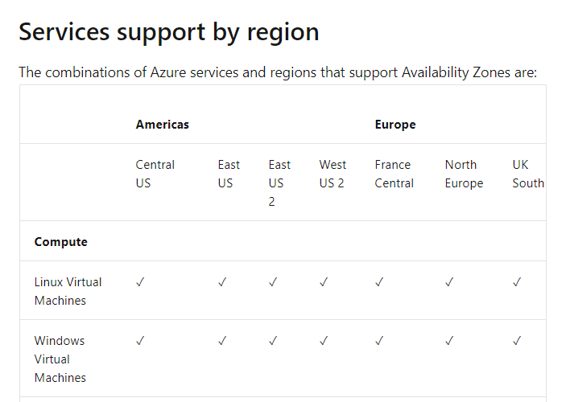

For more information on availability zones, please visit the below URL-

<https://docs.microsoft.com/en-us/azure/availability-zones/az-overview>

Parte inferior do formulário

Parte superior do formulário

Pergunta 17: **Correto**

Can region pairs be used to replicate data asynchronously across multiple regions for disaster recovery protection?

* 

**A. Yes**

**(Correto)**

* 

**B. No**

**Explicação**

**Answer: A**

Availability Zones are only specific to a region.

The Microsoft documentation mentions the following.

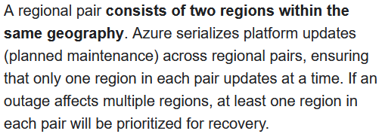

For more information on availability zones, please visit the below URL-

* <https://docs.microsoft.com/en-us/azure/availability-zones/az-overview>
* <https://docs.microsoft.com/en-us/azure/availability-zones/cross-region-replication-azure>

Parte inferior do formulário

Parte superior do formulário

Pergunta 18: **Correto**

A company is planning to make use of Azure Service Health. Would the company administrator be able to view the health of the Azure resources related to their subscription?

* 

**A. Yes**

**(Correto)**

* 

**B. No**

**Explicação**

**Answer: A**

If you go to Service Health and Resource Health, you can see the health of your resources as shown below.

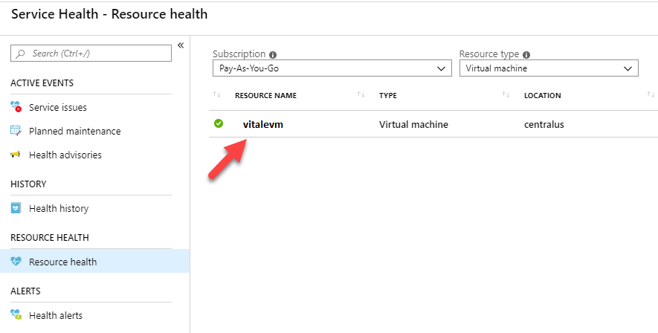

And if you go to Service Issues, you can see any issues with the underlying Azure Infrastructure.

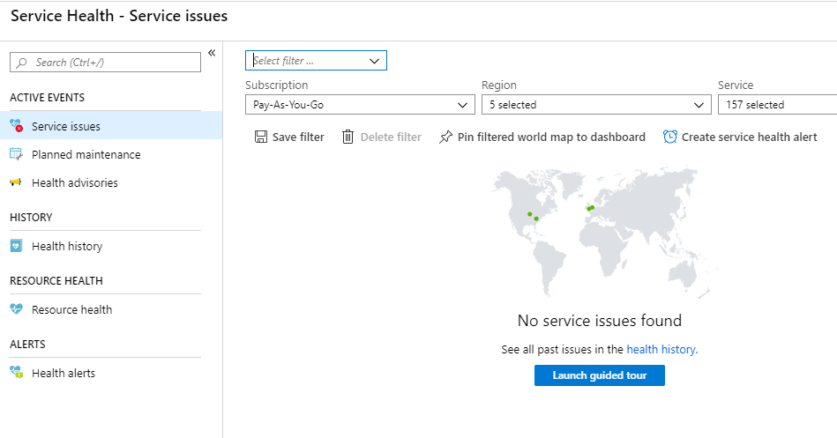

For more information on Azure Service Health, please visit the below URL-

<https://azure.microsoft.com/en-in/features/service-health/>

Parte inferior do formulário

Parte superior do formulário

Pergunta 19: **Incorreto**

A company wants to make use of the Azure Service Health. Using this service, could the company administrator create a rule that sends alerts when an Azure service fails?

* 

**A. Yes**

**(Correto)**

* 

**B. No**

**(Incorreto)**

**Explicação**

**Answer: A**

In Service Health, one can go to the “Health alerts” section and create a service health alert.

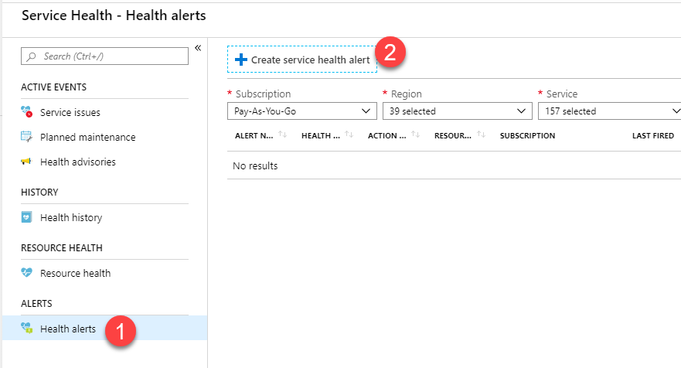

For more information on Azure Service Health, please visit the below URL-

<https://azure.microsoft.com/en-in/features/service-health/>

Parte inferior do formulário

Parte superior do formulário

Pergunta 20: **Correto**

A company wants to make use of Azure Service Health. Using only this service, would the company administrator prevent a service failure from affecting a chosen Azure virtual machine?

* 

**A. Yes**

* 

**B. No**

**(Correto)**

**Explicação**

**Answer: B**

The Azure Service Health service is used to monitor the health of the underlying infrastructure that is used to host Azure-based services. You cannot use this service to prevent the service failure of an Azure virtual machine.

If you want to increase the availability of your virtual machines, consider deploying the virtual machines across an availability set or an availability zone.

For more information on the Azure Service Health, please visit the following URL-

<https://azure.microsoft.com/en-us/features/service-health/>

Parte inferior do formulário

Parte superior do formulário

Pergunta 21: **Incorreto**

You have to identify the correct concept behind each of the following cloud service descriptions. Which of the following is the right concept behind the following description?

***“A cloud service that can be accessed quickly by users over the Interne****t****(*Quick response time is important to users)*”***

* 

**A. Fault Tolerance**

* 

**B. Disaster Recovery**

**(Incorreto)**

* 

**C. Dynamic Scalability**

* 

**D. Low Latency**

**(Correto)**

**Explicação**

**Answer: D**

This is an example of low latency.

Following is a snippet from a Microsoft blog article.

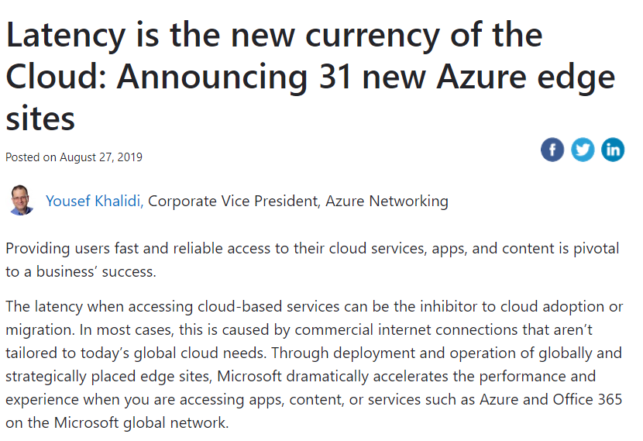

Option A is incorrect since this is used to ensure that a service is running even in the event of a service failure.

Option B is incorrect since this is used to ensure that a service is running even in the event of a catastrophic loss.

Option C is incorrect since this is used to ensure that a service is scalable even when the load on the service increases.

For more information on the article, please visit the below URL-

<https://azure.microsoft.com/en-us/blog/latency-is-the-new-currency-of-the-cloud-announcing-31-new-azure-edge-sites/>

Parte inferior do formulário

Parte superior do formulário

Pergunta 22: **Correto**

You have to match the Azure Cloud Service benefit to the right description. Which of the following is the right Azure Cloud Service benefit that matches the following description?

**“A cloud service that is able to perform as per the Service Level Agreement even after the load on the service increases.”**

* 

**A. Fault Tolerance**

* 

**B. Disaster Recovery**

* 

**C. Dynamic Scalability**

**(Correto)**

* 

**D. Low Latency**

**Explicação**

**Answer: C**

This aligns itself with the concept of scalability.

Azure has a service that helps in Autoscaling.

Option A is incorrect since this is used to ensure that a service is running even in the event of a service failure.

Option B is incorrect since this is used to ensure that a service is running even in the event of a catastrophic loss.

Option D is incorrect since this is used to ensure that a service is quickly accessible to users over the Internet.

For more information on Azure Autoscale, please visit the below URL-

<https://azure.microsoft.com/en-us/features/autoscale/>

Parte inferior do formulário

Parte superior do formulário

Pergunta 23: **Correto**

You have to match the Azure Cloud Service benefit to the right description. Which of the following is the right Azure Cloud Service benefit that matches the following description?

**“A cloud service that can be restored in the event of a catastrophic loss.”**

* 

**A. Fault Tolerance**

* 

**B. Disaster Recovery**

**(Correto)**

* 

**C. Dynamic Scalability**

* 

**D. Low Latency**

**Explicação**

**Answer: B**

This term refers to disaster recovery.

Below is a snippet from the Microsoft documentation on the terminology.

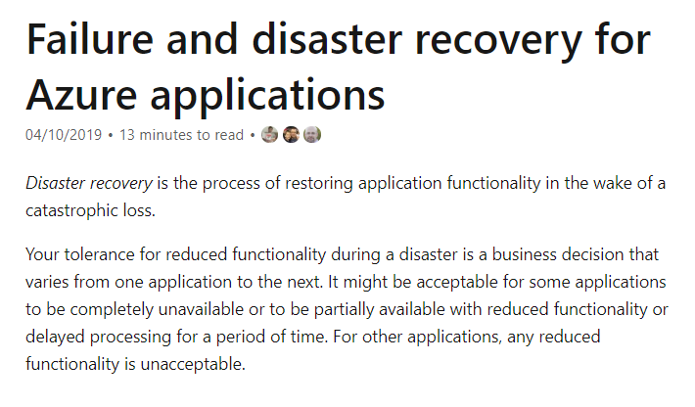

Option A is incorrect since this is used to ensure that a service is running even in a service failure event.

Option C is incorrect since this is used to ensure that a service is scalable even when it increases.

Option D is incorrect since this is used to ensure that a service is quickly accessible to users over the Internet.

For more information on failure and disaster recovery, please visit the below URL-

<https://docs.microsoft.com/en-us/azure/architecture/reliability/disaster-recovery>

Parte inferior do formulário

Parte superior do formulário

Pergunta 24: **Correto**

You have to match the Azure Cloud Service benefit to the right description. Which of the following is the right Azure Cloud Service benefit that matches the following description?

**“A cloud service that remains available even if a fault occurs in the service.”**

* 

**A. High Availability**

**(Correto)**

* 

**B. Disaster Recovery**

* 

**C. Dynamic Scalability**

* 

**D. Low Latency**

**Explicação**

**Answer: A**

This corresponds to “High Availability” or “Resiliency”.

Below is a snippet from the Microsoft documentation on the terminology.

<https://docs.microsoft.com/en-us/azure/virtual-machines/workloads/sap/sap-high-availability-architecture-scenarios>

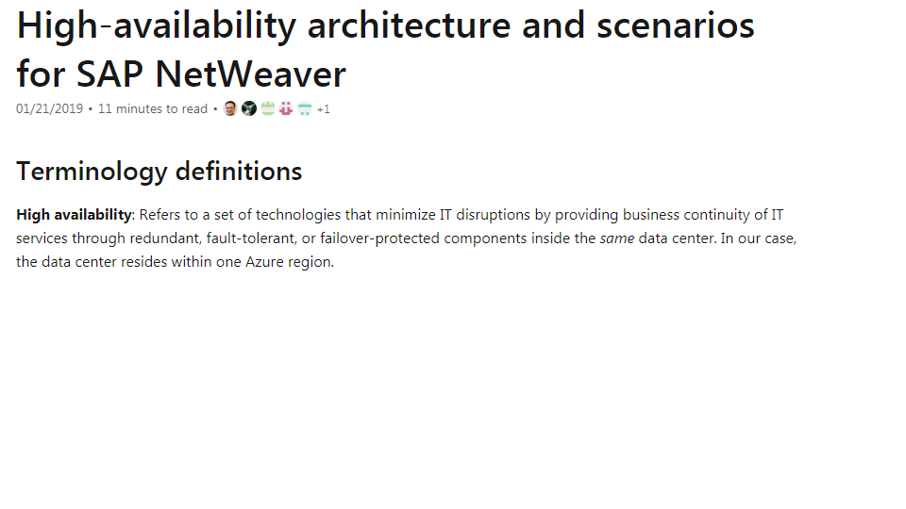

Option B is incorrect since this is used to ensure that a service is running even in the event of a catastrophic loss.

Option C is incorrect since this is used to ensure that a service is scalable even when the load on the service increases.

Option D is incorrect since this is used to ensure that a service is quickly accessible to users over the Internet.

For more information on designing reliable applications, please visit the below URL-

<https://docs.microsoft.com/en-us/azure/architecture/reliability/>

Parte inferior do formulário

Parte superior do formulário

Pergunta 25: **Incorreto**

A company needs to deploy a server named “whizlabserver” to the Azure cloud. The company’s requirement states that the server needs to be deployed on a separate network segment. Which of the following could be used to deploy the server to ensure that it meets the company requirement?

* 

**A. A separate resource group**

* 

**B. A separate virtual network**

**(Correto)**

* 

**C. A separate network interface for the server**

**(Incorreto)**

* 

**D. A separate account for the server**

**Explicação**

**Answer: B**

If the server needs to be isolated, then consider deploying a new virtual network for the server.

The Microsoft documentation mentions the following.

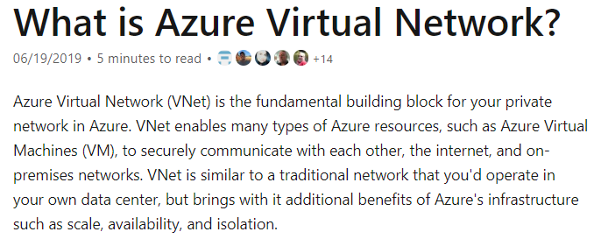

All other options are invalid since they would not provide a means of isolation for the server.

For more information on virtual networks, please visit the below URL-

<https://docs.microsoft.com/en-us/azure/virtual-network/virtual-networks-overview>

Parte inferior do formulário

Parte superior do formulário

Pergunta 26: **Incorreto**

A company is planning to set up a solution on the Azure platform. The solution has the following main key requirement.

* Provide the ability to route traffic to backend virtual machines based on the attributes of an HTTP request.

Which of the following would be best suited for this requirement?

* 

**A. Azure Data Lake Storage**

**(Incorreto)**

* 

**B. Azure Application Gateway**

**(Correto)**

* 

**C. Azure Storage Accounts**

* 

**D. Azure SQL Data Warehouse**

**Explicação**

**Answer: B**

This can be achieved with the Azure Application Gateway.

The Microsoft documentation mentions the following.

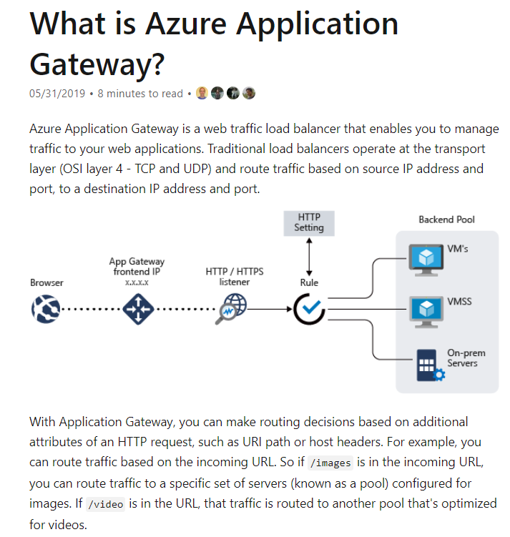

Since this is clearly mentioned in the documentation, all other options are incorrect.

For more information on the Azure Application gateway service, please visit the below URL-

<https://docs.microsoft.com/en-us/azure/application-gateway/overview>

Parte inferior do formulário

Parte superior do formulário

Pergunta 27: **Incorreto**

A company is planning to set up a solution on the Azure platform. The solution has the following main key requirement.

* Provide a service that could help store objects that could be accessed from anywhere around the world via HTTP.

Which of the following would be best suited for this requirement?

* 

**A. Azure Data Lake Storage**

* 

**B. Azure Application Gateway**

* 

**C. Azure Storage Accounts**

**(Correto)**

* 

**D. Azure SQL Data Warehouse**

**(Incorreto)**

**Explicação**

**Answer: C**

This can be achieved by the Azure Storage Accounts service.

The Microsoft documentation mentions the following.

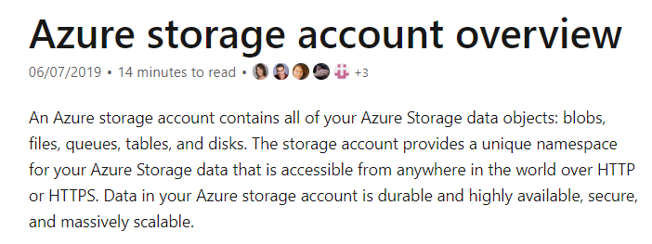

Since this is clearly mentioned in the documentation, all other options are incorrect.

For more information on the Azure Storage Accounts service, please visit the below URL-

<https://docs.microsoft.com/en-us/azure/storage/common/storage-account-overview>

Parte inferior do formulário

Parte superior do formulário

Pergunta 28: **Incorreto**

A company wants to implement Azure AD Identity Protection. Following are the key requirements:

* Prompt users if the credentials are compromised
* Identify suspicious login attempts

Which of the following policies implement the above requirements?

* 

**A.**

**User risk policy**

**(Correto)**

* 

**B.**

**Azure policy**

* 

**C.**

**Sign in risk policy**

**(Correto)**

* 

**D.**

**MFA registration policy**

**(Incorreto)**

**Explicação**

**Answers: A and C**

* **Option A is CORRECT,** it is used if the credentials are compromised
* **Option B is incorrect** as it is a Service to create policies in Azure
* **Option C is CORRECT,** it is considered for any suspicious sign-ins like multiple incorrect login attempts
* **Option D is incorrect,** it ensures that user registers for MFA

**Reference:**

* <https://docs.microsoft.com/en-us/azure/active-directory/authentication/tutorial-risk-based-sspr-mfa>

Parte inferior do formulário

Parte superior do formulário

Pergunta 29: **Incorreto**

A company wants to move all its employees to Azure Active Directory. What is the initial domain where the tenant is created?

* 

**A. onmicrosoft.com**

**(Correto)**

* 

**B. portal.azure.com**

* 

**C. azurewebsites.com**

**(Incorreto)**

* 

**D. microsoft.com**

**Explicação**

**Answer: A**

* **Option A is correct** as is used for the initial domain name should be onmicrosoft.com and Also, even the diagram included in the explanation indicates the initial domain is onmicrosoft.com.
* **Option B is incorrect**as portal.azure.com is the used for login into the Azure portal.
* **Option C is incorrect**as azurewebsites.com is used to host the web application in azure.
* **Option D is incorrect** as microsoft.com is Microsoft’s public site

Diagram:

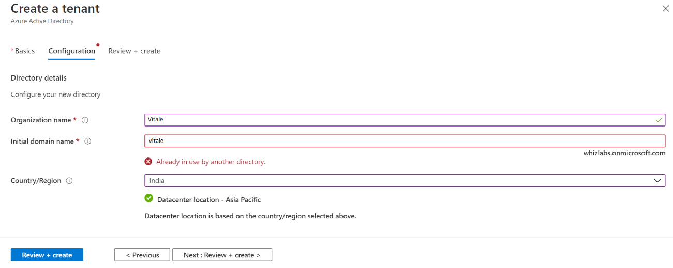

**Reference:**

* + <https://docs.microsoft.com/en-us/azure/active-directory/fundamentals/active-directory-whatis> to create a tenant

Parte inferior do formulário

Parte superior do formulário

Pergunta 30: **Incorreto**

Which of the following fills the three most important needs as you manage the security of your resources and workloads in the cloud and on-premises?

**Three vital needs**

* Assess
* Secure
* Defend
* 

**A. Azure Storage Accounts**

* 

**B. Microsoft Defender for Cloud**

**(Correto)**

* 

**C. Azure Active Directory (Azure AD)**

**(Incorreto)**

* 

**D. Microsoft Sentinel**

**Explicação**

**Answer: B**

**Microsoft Defender for Cloud**fills three vital needs as you manage the security of your resources and workloads in the cloud and on-premises:

* **Continuously assess –** Know your security posture. Identify and track vulnerabilities.
* **Secure –**Harden resources and services with Azure Security Benchmark.
* **Defend –** Detect and resolve threats to resources, workloads, and services.

Option A is incorrect: An Azure storage account **contains all of your Azure Storage data objects, including blobs, file shares, queues, tables, and disks**.

Option C is incorrect: Azure Active Directory (Azure AD) is **a cloud-based identity and access management service**.

Option D is incorrect: Microsoft Sentinel is **a cloud-native security information and event manager (SIEM) platform** that uses built-in AI to help analyze large volumes of data across an enterprise—fast.

**Reference**:

[Describe Microsoft Defender for Cloud - Training | Microsoft Docs](https://docs.microsoft.com/en-us/training/modules/describe-azure-identity-access-security/9-describe-microsoft-defender-for-cloud?ns-enrollment-type=learningpath&ns-enrollment-id=learn.wwl.azure-fundamentals-describe-azure-architecture-services)

Parte inferior do formulário

Parte superior do formulário

Pergunta 31: **Incorreto**

A company wants to start using Azure. They want to have a declarative way to orchestrate the deployment of various resources types such as role assignments and policy assignments.

They decide to use Azure Information Protection.

Would this fulfill the requirement?

* 

**A. Yes**

**(Incorreto)**

* 

**B. No**

**(Correto)**

**Explicação**

**Answer: B**

This feature is used to secure email, documents and other sensitive data.

The Microsoft documentation mentions the following.

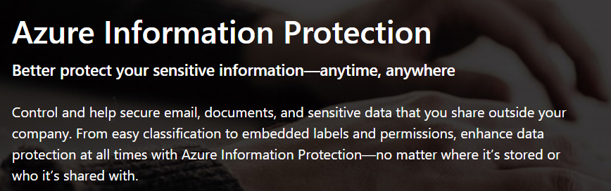

For more information on the Azure Information Protection, please visit the below URL-

<https://azure.microsoft.com/en-us/services/information-protection/>

Parte inferior do formulário

Parte superior do formulário

Pergunta 32: **Correto**

A company wants to start using Azure. They want to have a declarative way to orchestrate the deployment of various resources types such as role assignments and policy assignments.

They decide to use Azure Blueprints.

Would this fulfill the requirement?

* 

**A. Yes**

**(Correto)**

* 

**B. No**

**Explicação**

**Answer: A**

This would fulfill the requirement.

The Microsoft documentation mentions the following.

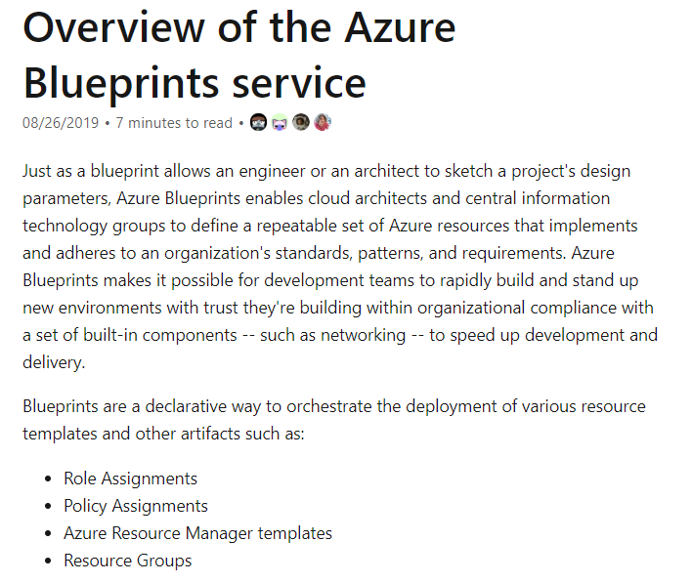

For more information on the Azure Blueprints, please visit the below URL-

<https://docs.microsoft.com/en-us/azure/governance/blueprints/overview>

Parte inferior do formulário

Parte superior do formulário

Pergunta 33: **Incorreto**

A company wants to start using Azure. They want to have a declarative way to orchestrate the deployment of various resources types such as role assignments and policy assignments.

They decide to use Azure AD Privileged Identity Management.

Would this fulfill the requirement?

* 

**A. Yes**

**(Incorreto)**

* 

**B. No**

**(Correto)**

**Explicação**

**Answer: B**

This is used to manage, control and monitor access to critical resources in Azure.

The Microsoft documentation mentions the following.

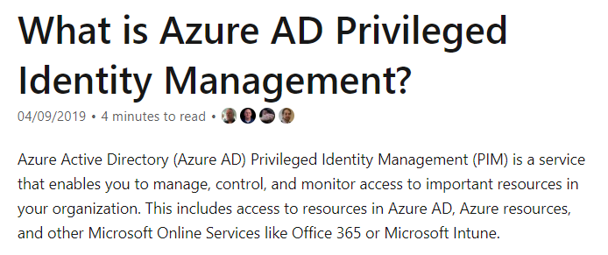

For more information on the Azure privileged identity management, please visit the below URL-

<https://docs.microsoft.com/en-us/azure/active-directory/privileged-identity-management/pim-configure>

Parte inferior do formulário

Parte superior do formulário

Pergunta 34: **Incorreto**

You just have started the deployment of an Azure Virtual machine to Azure. Where would you get a notification in the Azure portal on the completion of the deployment?



* 

**A. Using Link 1**

**(Incorreto)**

* 

**B. Using Link 2**

* 

**C. Using Link 3**

**(Correto)**

* 

**D. Using Link 4**

**Explicação**

**Answer: C**

You will receive a notification in the Notification section.

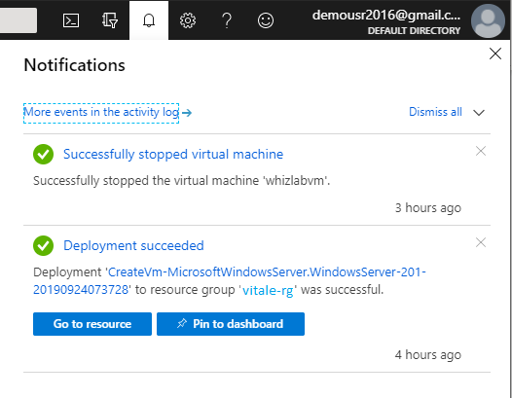

Since this is clear from the implementation, all other options are incorrect.

For more information on getting started with the Azure Portal, please visit the below URL-

<https://azure.microsoft.com/en-us/resources/videos/get-started-with-azure-portal/>

Parte inferior do formulário

Parte superior do formulário

Pergunta 35: **Incorreto**

A company has just deployed a set of Azure virtual machines. They want their IT administrative team to get alerts whenever the CPU of the virtual machines goes beyond a certain threshold. Which of the following service could be used for this requirement?

* 

**A. Azure Advisor**

* 

**B. Azure Security Center**

* 

**C. Azure Monitor**

**(Correto)**

* 

**D. Azure Active Directory**

**(Incorreto)**

**Explicação**

**Answer: C**

You can create alerts in Azure Monitor based on the virtual machine metrics.

The Microsoft documentation mentions the following.

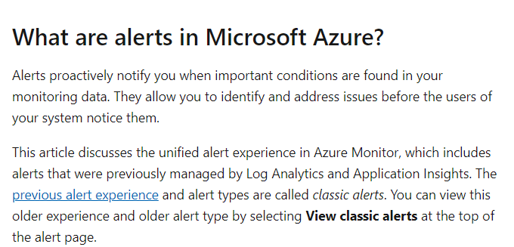

For more information on alerts in Azure Monitor, please visit the below URL-

<https://docs.microsoft.com/en-us/azure/azure-monitor/platform/alerts-overview>

Parte inferior do formulário

Parte superior do formulário

Pergunta 36: **Incorreto**

A company is planning to use the Azure Database service. Could they use the Azure Database Migration Service to migrate their current on-premises Microsoft SQL Server database to the Azure SQL database instance?

* 

**A. Yes**

**(Correto)**

* 

**B. No**

**(Incorreto)**

**Explicação**

**Answer: A**

Yes, you can accomplish this with the Database Migration Service.

The Microsoft documentation mentions the following.

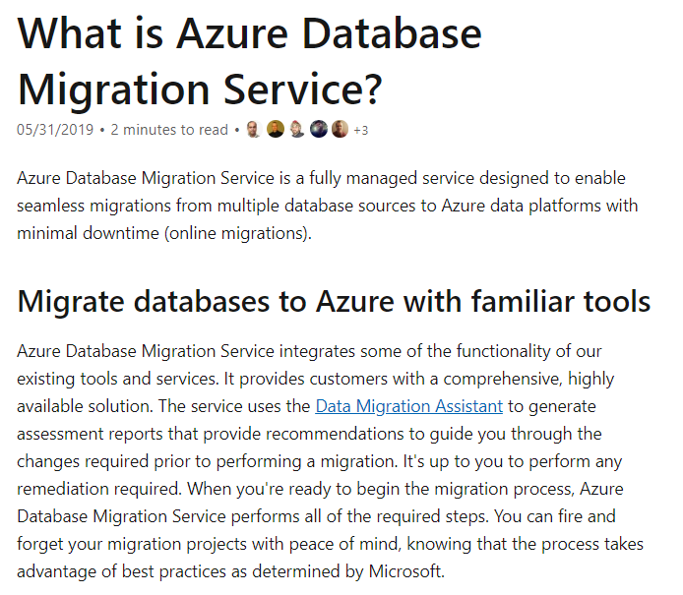

For more information on the Database Migration Service, please visit the below URL-

<https://docs.microsoft.com/en-us/azure/dms/dms-overview>

Parte inferior do formulário

Parte superior do formulário

Pergunta 37: **Incorreto**

Would the Azure Hybrid Benefit for Windows Server allow a customer to use his existing on-premises Windows Server licenses?

* 

**A. Yes**

**(Correto)**

* 

**B. No**

**(Incorreto)**

**Explicação**

**Answer: A**

They can make use of the Azure Hybrid Benefit to use the user's existing on-premises Windows Server Licenses.

The Microsoft documentation mentions the following.

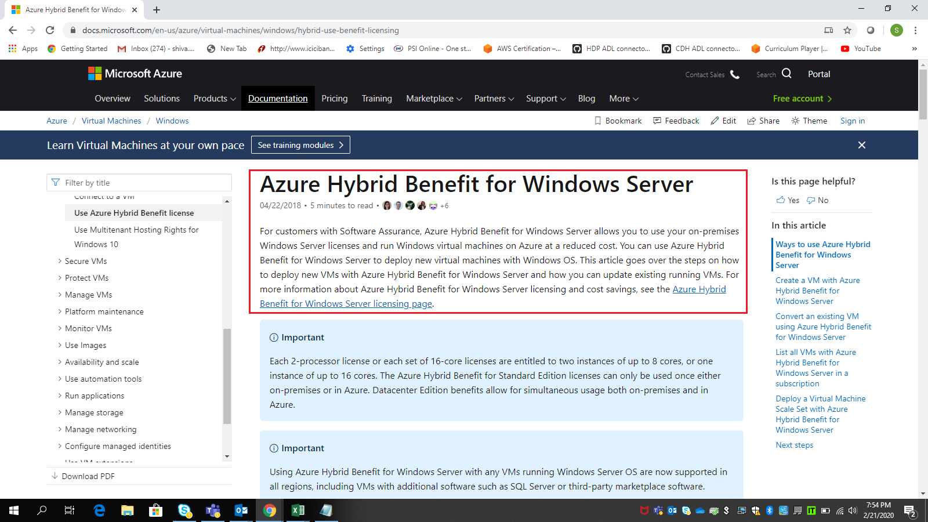

For more information on the Hybrid Benefit model, please visit the below URL-

<https://docs.microsoft.com/en-us/azure/virtual-machines/windows/hybrid-use-benefit-licensing>

Parte inferior do formulário

Parte superior do formulário

Pergunta 38: **Incorreto**

A company is planning to use the Azure Cosmos DB service. Does the Cosmos DB service provide the ability to access data using different types of APIs such as that of Mongo DB and Cassandra?

* 

**A. Yes**

**(Correto)**

* 

**B. No**

**(Incorreto)**

**Explicação**

**Answer: A**

Cosmos DB is a multi-model database.

The Microsoft documentation mentions the following.

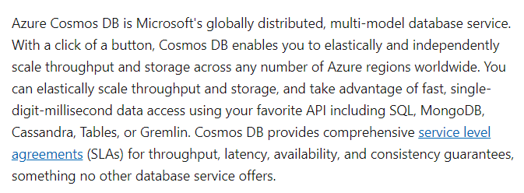

For more information on Azure Cosmos DB, please visit the below URL-

<https://docs.microsoft.com/en-us/azure/cosmos-db/introduction>

Parte inferior do formulário

Parte superior do formulário

Pergunta 39: **Incorreto**

A company is planning to use the Azure Cosmos DB service. Would the company need to manage indexes on the Azure Cosmos DB server?

* 

**A. Yes**

**(Incorreto)**

* 

**B. No**

**(Correto)**

**Explicação**

**Answer: B**

Cosmos DB is a fully managed service where no schema and index management is required.

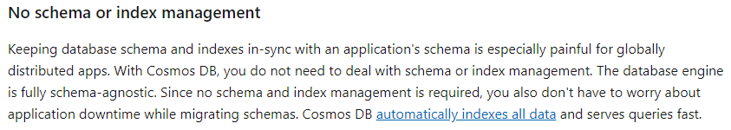

For more information on Azure Cosmos DB, please visit the below URL-

<https://docs.microsoft.com/en-us/azure/cosmos-db/introduction>

Parte inferior do formulário

Parte superior do formulário

Pergunta 40: **Correto**

A company is planning to use the Azure Cosmos DB service. Do you need to define a predefined schema for the tables on Cosmos DB?

* 

**A. Yes**

* 

**B. No**

**(Correto)**

**Explicação**

**Answer: B**

Cosmos DB is based on a schema-less design.

The Microsoft documentation mentions the following.

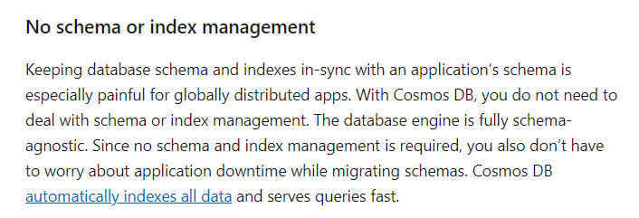

For more information on Azure Cosmos DB, please visit the below URL-

<https://docs.microsoft.com/en-us/azure/cosmos-db/introduction>

Parte inferior do formulário

Parte superior do formulário

Pergunta 41: **Correto**

A company has deployed a number of virtual machines to their Azure subscription. They want to know if there are any recommendations to have a reduction in costs for running the virtual machines in Azure. Which of the following would help in this regard?

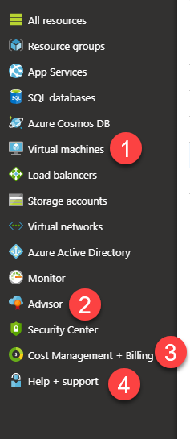

* 

**A. Virtual Machines**

* 

**B. Advisor**

**(Correto)**

* 

**C. Cost Management + Billing**

* 

**D. Help + support**

**Explicação**

**Answer: B**

If you look at Azure Advisor, it can actually give you a purchase recommendation on how you can reduce costs when it comes to Virtual machines. Below is an example.

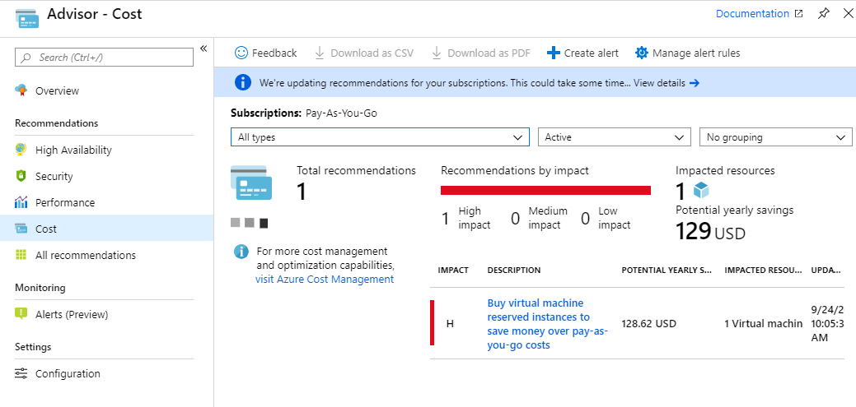

Since this is clear from the implementation, all other options are incorrect.

For more information on Azure Advisor Cost Recommendations, please visit the below URL-

<https://docs.microsoft.com/en-us/azure/advisor/advisor-cost-recommendations>

Parte inferior do formulário

Parte superior do formulário

Pergunta 42: **Incorreto**

A company wants to implement Azure Multi-Factor Authentication. Which of the following is the recommended policy?

* 

**A. Enable per-user**

* 

**B. Enable per-session**

**(Incorreto)**

* 

**C. Enable Conditional Access**

**(Correto)**

* 

**D. Enable Security Defaults**

**Explicação**

**Answer: C**

* **Option A is incorrect**as it is not advised per user, as it would be time consuming and difficult to maintain for large number of users
* **Option B is incorrect**because session is per user login and policy is not applied on user session
* **Option C is CORRECT**because it would help to provide the access for group of users and helps in managing efficiently
* **Option D is incorrect** because it is applicable for free tier by default

**Diagram:**

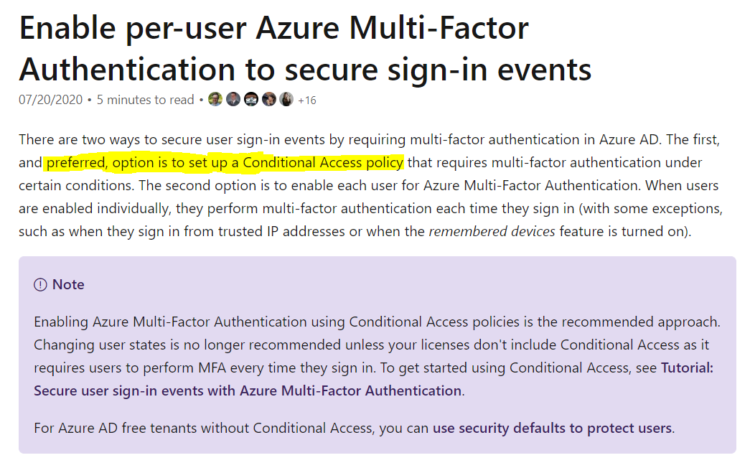

**Reference:**

* + <https://docs.microsoft.com/en-us/azure/active-directory/authentication/howto-mfa-userstates>

Parte inferior do formulário

Parte superior do formulário

Pergunta 43: **Incorreto**

Your Company has multiple subscriptions and wants to implement a custom Dashboard which would display the Secure Score for each subscription.

Which of the following is a valid option?

* 

**A. Not possible to implement Secure Score on to a custom Dashboard**

* 

**B. Can be implemented for only single subscription**

* 

**C. Can be implemented using Secure Score REST API**

**(Correto)**

* 

**D. Not possible, Secure score is only accessible through the Azure Portal**

**(Incorreto)**

**Explicação**

**Answer: C**

* **Option A is incorrect**because Secure Score can be accessed using REST API
* **Option B is incorrect** because using REST API, Secure Score can be retrieved for multiple subscriptions
* **Option C is CORRECT,**please see the reference url, accessing your secure score section
* **Option D is incorrect**because Secure score can be accessed through REST API

**References:**

* <https://docs.microsoft.com/en-us/azure/security-center/secure-score-security-controls>
* <https://docs.microsoft.com/en-us/graph/api/securescore-get?view=graph-rest-1.0&tabs=http>

Parte inferior do formulário

Parte superior do formulário

Pergunta 44: **Incorreto**

A company currently has deployed 2 virtual machines to Azure. The virtual machines would be hosting a web application. Users would be using the web application from the Internet. Would the addition of a VPN gateway to the solution increase the availability of the application?

* 

**A. Yes**

**(Incorreto)**

* 

**B. No**

**(Correto)**

**Explicação**

**Answer: B**

The VPN gateway is used to create Virtual Private connections between the on-premises data center and an Azure network.

The Microsoft documentation mentions the following.

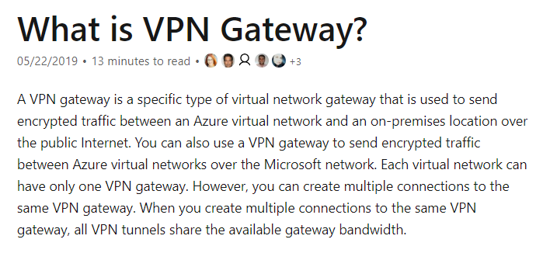

For more information on the VPN gateway service, please visit the below URL-

<https://docs.microsoft.com/en-us/azure/vpn-gateway/vpn-gateway-about-vpngateways>

Parte inferior do formulário

Parte superior do formulário

Pergunta 45: **Correto**

A company currently has deployed 6 virtual machines to Azure. The virtual machines would be hosting a web application. Users would be using the web application from the Internet. Would the use of an Azure Load balancer help to increase the availability of the web application?

* 

**A. Yes**

**(Correto)**

* 

**B. No**

**Explicação**

**Answer: A**

Yes, you can achieve higher availability for your applications by adding a load balancer to the architecture.

The Microsoft documentation mentions the following.

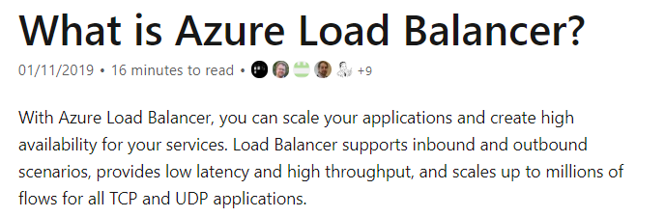

For more information on the Azure Load Balancer, please visit the below URL-

<https://docs.microsoft.com/en-us/azure/load-balancer/load-balancer-overview>

Parte inferior do formulário

Parte superior do formulário

Pergunta 46: **Incorreto**

A company currently has deployed 6 Virtual Machines that are all identical to Azure. The virtual machines would be hosting a web application. Users would be using the web application from the Internet. Would it be better to deploy the virtual machines as part of an Azure Virtual machine scale set to increase the availability of the application?.

* 

**A. Yes**

**(Correto)**

* 

**B. No**

**(Incorreto)**

**Explicação**

**Answer: A**

Yes, you can achieve higher availability for your applications by adding the virtual machines to a virtual machine scale set.

The Microsoft documentation mentions the following.

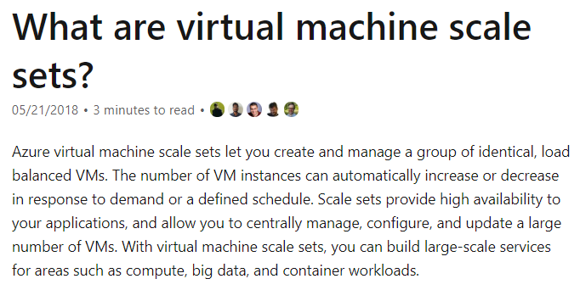

For more information on Virtual Machine scale sets, please visit the below URL-

<https://docs.microsoft.com/en-us/azure/virtual-machine-scale-sets/overview>

Parte inferior do formulário

Parte superior do formulário

Pergunta 47: **Incorreto**

A company wants to make use of a data store on the Azure platform. The data store would be used to store binary data (images, files, and documents).

The company decides to create an Azure Storage Account and then use the Blob service to store the binary data.

Is this the ideal service to use for this requirement?

* 

**A. Yes**

**(Correto)**

* 

**B. No**

**(Incorreto)**

**Explicação**

**Answer: A**

**Azure Blob storage is Microsoft's object storage** solution for the cloud. Blob storage is optimized for **storing massive amounts of unstructured data**. Unstructured data is data that doesn't adhere to a particular data model or definition, **such as text or binary data.**

You can use Blob storage to expose data publicly to the world or to store application data privately. Common uses of Blob storage include: Serving images or documents directly to a browser.

Azure Blob storage mechanism helps serve images or documents directly to a browser and stores files for distributed access. Such a distributed system also allows you to stream videos and audio.

The Microsoft documentation mentions the following.

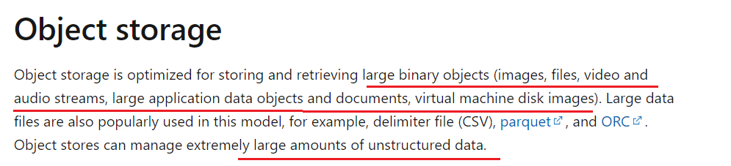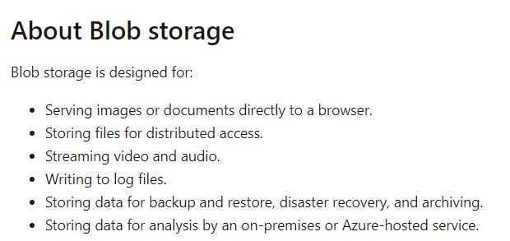

For more information on Azure Blob storage, please visit the below URL-

[Introduction to Blob (object) storage - Azure Storage | Microsoft Docs](https://docs.microsoft.com/en-us/azure/storage/blobs/storage-blobs-introduction)

[Understand data store models - Azure Application Architecture Guide | Microsoft Docs](https://docs.microsoft.com/en-us/azure/architecture/guide/technology-choices/data-store-overview#object-storage)

Parte inferior do formulário

Parte superior do formulário

Pergunta 48: **Correto**

A company wants to store application-related user data into Azure. They decide to create an Azure Storage Account. They then decide to use the File service to store the user data.

Is this the ideal service for the storage of user-related data?

* 

**A. Yes**

* 

**B. No**

**(Correto)**

**Explicação**

**Answer: B**  
  
Azure SQL Database is a great service for storing and retrieving complex, relational data, potentially optimized for geographic performance.

File service is not the ideal service. Table service or database service is ideal.

Here are several advantages to using Azure storage irrespective of type. Azure storage is easily scalable, extremely flexible, and relatively low in cost depending on the options you choose.

There are 4 types of storage in Azure, namely:

* File
* Blob
* Queue
* Table

**Azure File Storage**

Azure file storage makes it easy to move applications that depend on regular file shares to the cloud. File storage uses the SMB 2.1 or 3.0 protocol and can be accessed by multiple applications simultaneously. There are some SMB features that are not currently supported. For a complete list, see this link.

File storage encompasses 4 component types:

* Account
* This is your Azure storage account, in which you created your main file share.
* Share
* File shares created in the main file share. Share names can be 63 characters long.
* Directory
* Any hierarchy of folders and directories. Directory names can be up to 255 characters long.
* Files
* Any files uploaded to the share, to a maximum size of 1 TB.

**Create a file share**

To create a file share, click on your storage account and select Files as the type of service you want.

On the File service screen:

* Click on + File share

Then enter the:

* Name
* The name you want to give the file share
* Quota
* The quote you want to allocate to the file share. This can be anywhere from 1 GB to approximately 5 TB.
* Click on OK.

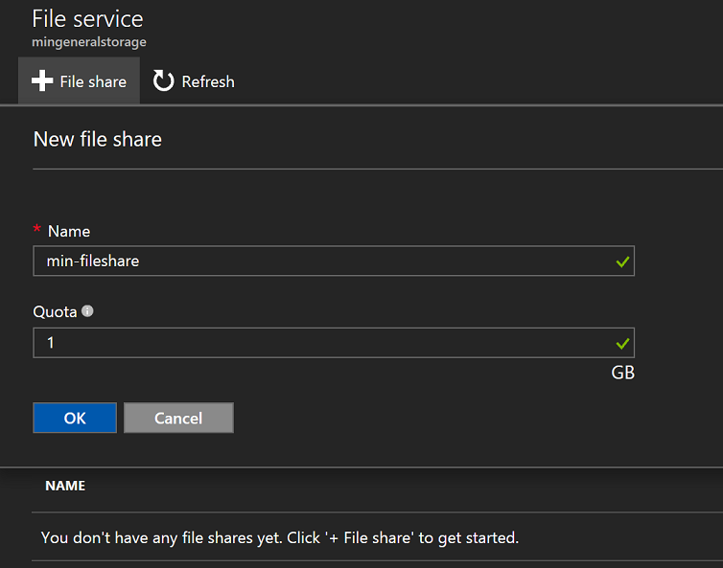

You can then proceed to click on the file share and create directories or add files just as you would with a normal file share.

<https://docs.microsoft.com/en-us/azure/architecture/guide/technology-choices/data-store-overview>

For more information on the Azure File service, please visit the below URL-

<https://docs.microsoft.com/en-us/azure/storage/files/storage-files-introduction>

Parte inferior do formulário

Parte superior do formulário

Pergunta 49: **Incorreto**

A company wants to store application-related user data into Azure. They decide to create an Azure Storage Account. They then decide to use the Table service to store the user data.

Is this the ideal service for storage of user related data?

* 

**A. Yes**

**(Correto)**

* 

**B. No**

**(Incorreto)**

**Explicação**

**Answer: A**

Yes, this is the ideal service for storing application-related user data.

The Microsoft documentation mentions the following.

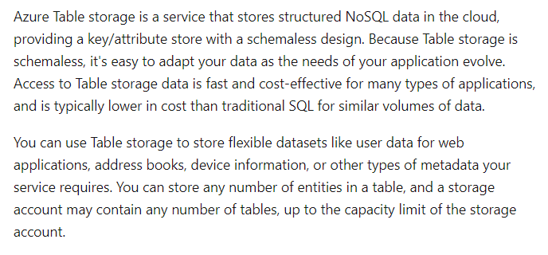

For more information on Azure Table storage, please visit the below URL-

<https://docs.microsoft.com/en-us/azure/cosmos-db/table-storage-overview>

Parte inferior do formulário

Parte superior do formulário

Pergunta 50: **Correto**

A company wants to start using Azure. They want to deploy several resources to their Azure subscription. They want to be informed of the costs of Azure resources that go beyond a certain threshold. Which of the following can help achieve this?

* 

**A. Create an alert in Azure Monitor.**

* 

**B. Create a budget in Azure Cost Management.**

**(Correto)**

* 

**C. Create an alert in Azure Advisor.**

* 

**D. Create a cost tag for the resource group.**

**Explicação**

**Answer: B**

You can create a budget and get a notification if the costs are going beyond the budget.

The Microsoft documentation mentions the following.

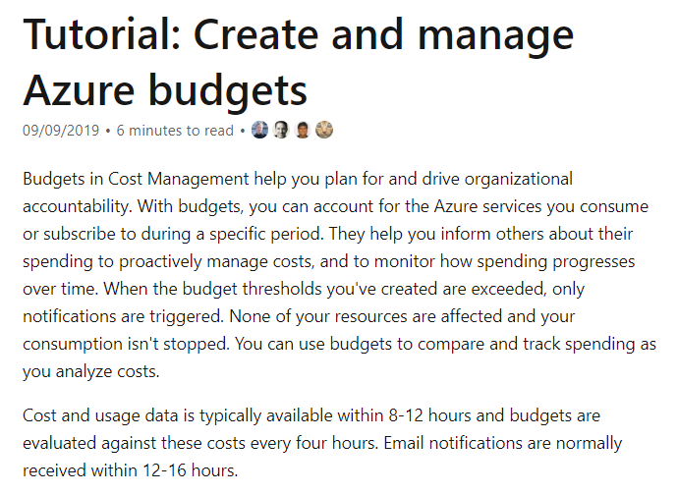

Since this is clearly mentioned in the Microsoft documentation, all other options are incorrect.

For more information on Azure budgets, please visit the below URL-

<https://docs.microsoft.com/en-us/azure/cost-management/tutorial-acm-create-budgets>

Parte inferior do formulário

Parte superior do formulário

Pergunta 51: **Incorreto**

You are planning to create an Azure Free Account. Which of the following is correct when it comes to the Azure Free Account? Choose 2 answers from the options given below.

* 

**A. You get free access to all services for 12 months.**

* 

**B. You get USD 200 worth of credit that you can spend during the first 30 days of sign-up.**

**(Correto)**

* 

**C. After the 30-day period or USD 200 worth of credit is over, you need to convert to a Pay-As-You-Go account.**

**(Correto)**

* 

**D. You only need to have a valid mobile number to sign-up for the account.**

**Explicação**

**Answer: B and C**

The following is mentioned in the Microsoft documentation to support the correct options.

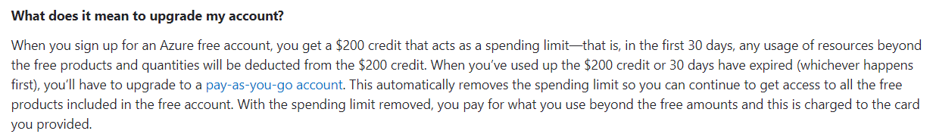



Option A is incorrect because you don’t get free access to ALL products, just the popular ones.

Option D is incorrect because you also need to have a credit card or Microsoft account in hand.

For more information on the Azure Free Account, please visit the below URL-

<https://azure.microsoft.com/en-us/free/free-account-faq/>

Parte inferior do formulário